The Sound of Safety
Don’t Let Electrical Cords Become Dangerous!

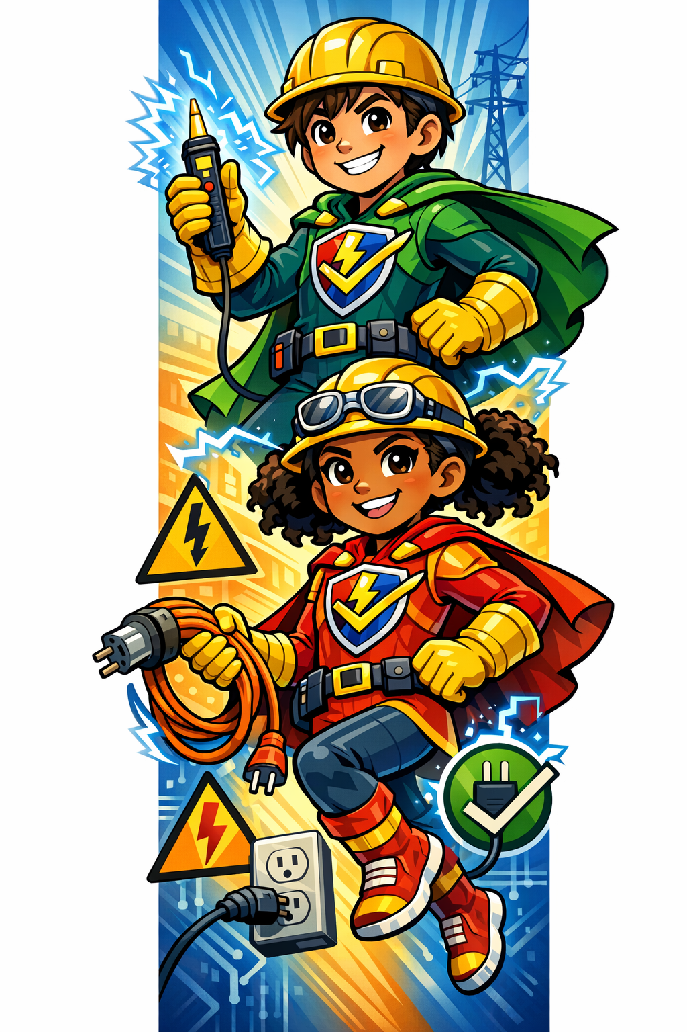
Kids Can Help Keep the Home Safe!

Hey Kids — Be an Electrical Safety Hero!
Talk to your parents about checking electrical cords and power strips around the house.

Electrical Cord Safety
Ask your parents:
- Are too many things plugged into one outlet or power strip?
- Are extension cords being used safely?
- Are any cords broken, cracked, or damaged?
- Are cords getting squished by furniture or doors?
- Are cords kept away from pets and busy walkways?

Remember:
- Too many plugs in one place can start a fire.
- Damaged cords can cause shocks or fires.
- Extension cords are for temporary use — not forever!

Be Smart Around Electricity
- Never touch damaged cords.
- Tell an adult if you see sparks, hot cords, or broken plugs.
- Keep cords neat and safe.

Safe Cords = Safe Homes!

Be a Safety Hero and remind your family to check cords and outlets today!

